EX No:1 | SETTING UP PYTHON ENVIRONMENT AND LIBRARIES – JUPYTER NOTEBOOK

Aim:
To install Python, configure Jupyter Notebook, understand the notebook environment, execute Python programs, create Markdown cells, and use basic Jupyter Notebook features for Data Analytics applications.

Algorithm:
Algorithm 1: Installing Python
- Download Python from python.org
- Run the installer
- Select "Add Python to PATH"
- Click Install Now
- Verify installation using: python --version
- Observe installed Python version

Algorithm 2: Installing Jupyter Notebook
- Open Command Prompt
- Install Jupyter pip install notebook
- Launch Jupyter Notebook jupyter notebook
- Browser automatically opens Notebook Dashboard.

Algorithm 3: Creating a Notebook
- Open Jupyter Dashboard
- Select New → Python 3
- Create Notebook
- Rename Notebook
- Create Code and Markdown Cells
- Execute cells using Shift + Enter

Program:
Program 1 — Simple Python Program
print("Welcome to Data Analytics Lab")
Output:
Welcome to Data Analytics Lab

Program 2 — Arithmetic Operations
a = 20
b = 10
print("Addition =", a + b)
print("Subtraction =", a - b)
print("Multiplication =", a * b)
print("Division =", a / b)
Output:
Addition = 30
Subtraction = 10
Multiplication = 200
Division = 2.0

Program 3 — Display Student Details
name = "John"
dept = "AI&DS"
cgpa = 8.9
print("Name:", name)
print("Department:", dept)
print("CGPA:", cgpa)
Output:
Name: John
Department: AI&DS
CGPA: 8.9

Program 4 — Creating Markdown Cell
# Data Analytics Lab
## Experiment 1
### Jupyter Notebook
Then press Shift + Enter.

Program 5 — Using NumPy Library
import numpy as np
a = np.array([10, 20, 30, 40, 50])
print(a)
print("Mean =", np.mean(a))
print("Sum =", np.sum(a))
Output:
[10 20 30 40 50]
Mean = 30.0
Sum = 150

Program 6 — Using Pandas Library
import pandas as pd
data = {
'Name': ['John', 'David', 'Alex'],
'Marks': [85, 90, 95]
}
df = pd.DataFrame(data)
print(df)
Output:
Name Marks
0 John 85
1 David 90
2 Alex 95

Program 7 — Data Visualization
import matplotlib.pyplot as plt
x = [1, 2, 3, 4, 5]
y = [10, 20, 15, 25, 30]
plt.plot(x, y)
plt.title("Sample Line Graph")
plt.xlabel("X Axis")
plt.ylabel("Y Axis")
plt.show()
Output:
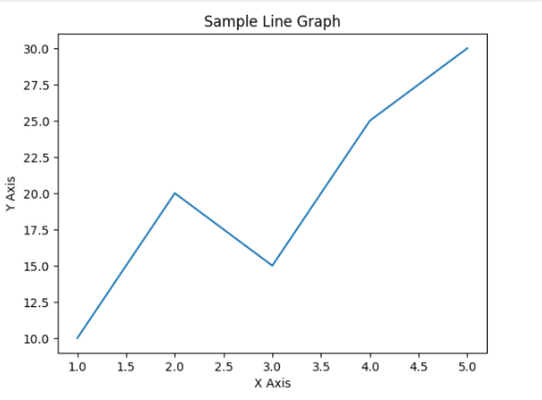

Result:

